Foundational Concepts

Network-Based Intrusion Detection System
Network-based IDSs systems are based on capturing network traffic and analyzing it to detect any potential intrusion, such as DoS attacks, port scanning, and botnets. Internally, a network-based IDS can use a signature-based approach and compare the collected information with a signature database to look for a match with an intrusion, or it can work as anomaly-based system and compare current behavior with normal behavior to decide whether there is an attack.
NIDS provides a high-level vantage point, allowing for the detection of reconnaissance and lateral movement before an individual host is compromised. In the context of this project, the NIDS acts as a behavioral sensor for the entire network highway.

2. The Hybrid Learning Dichotomy
Supervised Learning utilizes labeled datasets to recognize known attack signatures with high precision. Unsupervised Learning models "normal" behavior and flags deviations as potential anomalies. Project utilizes a Hybrid Approach, bridging these two paths to ensure the system can identify both historical, documented threats and novel, "Zero-Day" attacks that lack existing labels.

3. Explainable AI (XAI) and Decision Transparency
Explainability, implemented via frameworks like SHAP (SHapley Additive exPlanations), provides feature attribution. This allows a SOC analyst to understand why a specific flow was flagged for that instance, identifying a 500% spike in packet frequency thereby fostering trust and enabling rapid human verification. (Explaining the AI Core results).

4. Cryptographic Integrity and Digital Forensics
To ensure that security logs are admissible for investigation, we employ SHA-256 Hashing. This cryptographic algorithm generates a unique digital fingerprint for every log entry. If a log is altered after being recorded, the hash will change, providing a robust mechanism for Tamper Detection and ensuring the integrity of forensic evidence.

.

Strategic Methodologies

1. Signature-Based vs. Anomaly-Based Strategies
Historically, intrusion detection was Signature-Based, comparing traffic to a database of known malware strings. While effective for known threats, this strategy fails against polymorphic code. The modern Anomaly-Based Strategy focuses on behavior; by analyzing features such as Flow Duration, Symmetry, and Inter-Arrival Times (IAT), the system identifies shifts in network "tempo" that indicate an ongoing breach, regardless of the malware's signature.

2. Deep Flow Inspection (DFI) and Feature Extraction
Rather than performing Deep Packet Inspection (DPI) which is computationally expensive and often blocked by encryption this project utilizes Deep Flow Inspection (DFI). DFI analyzes the statistical properties of a "flow" (a sequence of packets between two points). By extracting behavioral features (e.g., packet counts, byte rates), the system creates a numerical profile of the traffic, which serves as the primary input for the detection engines.

3. Multi-Stage Detection Strategy
The strategic core of this architecture is its Dual-Engine flow:
- The Classification Layer: Uses boosting algorithms to categorize standardized threats found in established benchmarks like the CIC-IDS dataset.
- The Anomaly Layer: Uses reconstruction-based models to catch outliers that do not fit the "Normal" traffic profile, ensuring no unknown threat goes undetected.

Algorithms
.

1. Ensemble Learning: Random Forest (RF)
Random Forest is a "Bagging" technique that constructs a multitude of decision trees and outputs the class that is the mode of the classes. Its strength lies in its ability to handle High-Dimensional Data (such as the 80+ columns in our DFI dataset) without overfitting. It serves as a robust baseline for identifying complex, non-linear patterns in network traffic.

2. Gradient Boosting: XGBoost
XGBoost (Extreme Gradient Boosting) is the primary supervised engine for this project. Unlike RF, which builds trees in parallel, XGBoost builds them sequentially, where each new tree corrects the errors of the previous ones. It is selected for its superior Processing Speed and built-in L1/L2 Regularization, which prevents the model from being confused by the "noise" typically found in live network environments.

3. Reconstruction-Based Models: Autoencoders
To address the "Zero-Day" challenge, we utilize Autoencoders (a type of Neural Network). The strategy involves training the model to compress and then reconstruct "Normal" network traffic. When presented with an attack flow, the model fails to reconstruct it accurately; the resulting Reconstruction Error acts as a definitive signal for an anomaly.

4. Behavioral Clustering: DBSCAN/K-Means
For grouping similar attack types, Clustering algorithms are employed. By measuring the "distance" between different malicious flows in a multi-dimensional space, the system can identify coordinated botnet activity. This allow the analyst to see if multiple different IPs are part of the same distributed attack campaign.

COMPARISION OF ALGORITHM
Between Random Forest and XGBoost

Overview
Aspect | Random Forest | XGBoost
Type of Ensemble | Bagging (Bootstrap Aggregation) | Boosting (Gradient Boosting)
Learning Approach | Independent trees | Sequential learning (error correction)
Training Style | Parallel | Sequential
Tree Dependency | No dependency between trees | Each tree depends on previous ones
Prediction (Classification) | Majority voting | Sum of outputs + sigmoid/softmax
Prediction (Regression) | Average of outputs | Sum of outputs
Error Handling | Does not focus on individual errors | Focuses on minimizing residual errors
Over fitting Control | Controlled via randomness | Controlled via regularization (L1, L2)
Hyper parameter Tuning | Less tuning required | Requires careful tuning
Performance | Good baseline model | Generally higher accuracy
Speed (Training) | Faster (parallel processing) | Slower (sequential, but optimized)
Handling Missing Values | Requires preprocessing | Handles missing values internally
Complexity | Simple and easy to implement | More complex
Use Case | Quick models, less tuning | High accuracy, competitions, complex data

Research Articles:

Comparative Analysis of Random Forest and Xgboost Performance for Network Flow-Based Malware Classification
https://www.researchgate.net/publication/400947909_Comparative_Analysis_of_Random_Forest_and_Xgboost_Performance_for_Network_Flow-Based_Malware_Classification

Findings:

Hyper parameter tuning:

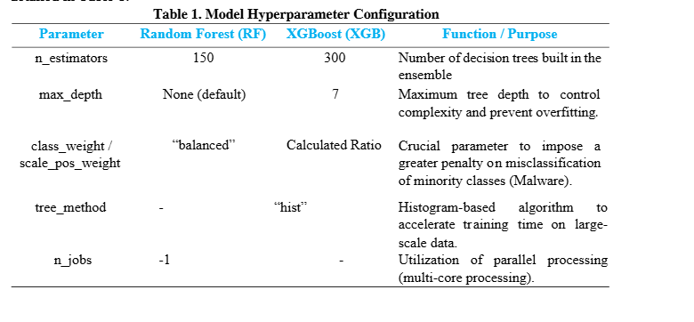

Confusion matrix:
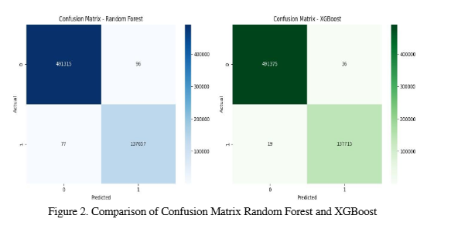

Metrics:
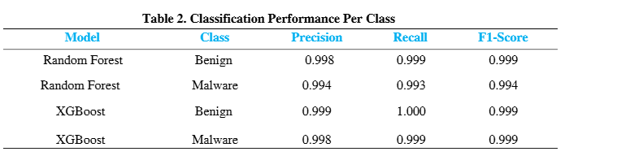

The most significant finding of this study lies in Inference Time efficiency. In a real-time Detection ecosystem, low latency is a critical parameter. The test results in Figure 6 show that XGBoost was able to complete predictions on ~600,000 test datasets in 6.36 seconds.

Time Comparison
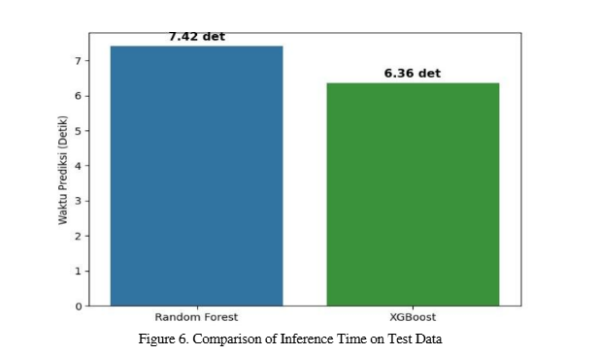

- A Hybrid Machine Learning Approach for Network Intrusion Detection with Real-Time Visualization
https://www.indjcst.com/archiver/archives/a_hybrid_machine_learning_approach_for_network_intrusion_detection_with_real_time_visualization.pdf

Findings

Metrics
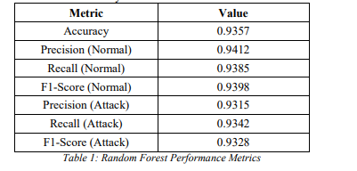

Detection rate
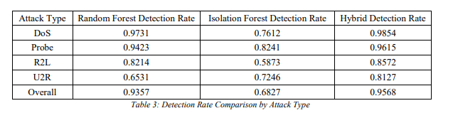

References

[1] Signature-based IDS cannot detect unknown/zero-day attacks
Khraisat, A., Gondal, I., Vamplew, P., & Kamruzzaman, J. (2019). Survey of intrusion detection systems: Techniques, datasets and challenges. Cybersecurity, 2, 20. Springer
https://link.springer.com/article/10.1186/s42400-019-0038-7
[2] Zero-day attacks are widespread and traditional detection methods fail against them
Alauthman, M. et al. (2023). A review of Machine Learning-based zero-day attack detection: Challenges and future directions. Computer Communications, 198. Elsevier/ScienceDirect.
https://www.sciencedirect.com/science/article/abs/pii/S0140366422004248
[3] NLP is needed to automate CTI extraction from unstructured sources
Bousquet et al. (2024). Actionable Cyber Threat Intelligence using Knowledge Graphs and Large Language Models. arXiv / WACCO Workshop.
https://arxiv.org/html/2407.02528v1

[4] ML + XAI (SHAP) for real-time IDS is an active research need
Larriva-Novo, X. et al. (2023). Leveraging Explainable Artificial Intelligence in Real-Time Cyberattack Identification. Applied Sciences, 13(15), 8587. MDPI.
https://www.mdpi.com/2076-3417/13/15/8587

1) MDPI — Cyber Threat Intelligence on Blockchain: A Systematic Literature Review
Authors: Dimitrios Chatziamanetoglou & Konstantinos Rantos
Title: Cyber Threat Intelligence on Blockchain: A Systematic Literature Review
Journal/Source: Computers (MDPI), Volume 13, Issue 3, Article 60, 2024
About: A systematic review exploring how blockchain technology is being used with Cyber Threat Intelligence (CTI) — covering models, methodologies, trends, and how blockchain's immutability, decentralization, and smart contracts enhance CTI data storage, sharing, trust, and security.
Link: https://www.mdpi.com/2073-431X/13/3/60
2) MDPI — Blockchain-Based Cyber Threat Intelligence System Architecture for Sustainable Computing
Authors: Jeonghun Cha, Sushil Kumar Singh, Yi Pan, & Jong Hyuk Park
Title: Blockchain-Based Cyber Threat Intelligence System Architecture for Sustainable Computing
Journal/Source: Sustainability (MDPI), Volume 12, Issue 16, Article 6401, 2020
About: Proposes a blockchain-enabled architecture for CTI systems that improves reliability, privacy, scalability, and sustainability of cyber threat intelligence data collection and sharing. Experimental results show improved resource efficiency versus traditional architectures.
Link: https://www.mdpi.com/2071-1050/12/16/6401
3) Nature — BlockIntelChain: a blockchain-based cyber threat intelligence sharing architecture
Authors: BlockIntelChain Research Contributors (Scientific Reports, Nature)
Title: BlockIntelChain: a blockchain-based cyber threat intelligence sharing architecture
Journal/Source: Scientific Reports (Nature), 2025
About: Introduces BlockIntelChain, a blockchain-based framework for decentralized, privacy-preserving CTI sharing, designed specifically for use with edge-deployed IoT and SOC environments. It highlights advantages over traditional CTI platforms (e.g., MISP, ThreatConnect) in decentralization, privacy, and cost efficiency.
Link: https://www.nature.com/articles/s41598-025-29152-6
4) IEEE — Documentation of MITRE ATT&CK (Device & Adversary Tactics)
Authors: MITRE / IEEE contributors
Title: Documentation of Attack: MITRE ATT&CK Framework
Journal/Source: IEEE Xplore, 2019
About: Official IEEE publication describing the MITRE ATT&CK framework, a comprehensive knowledge base of real-world adversary tactics, techniques, and procedures (TTPs) used for documenting and analysing cyberattacks in a structured way. This documentation is widely used for intrusion detection, threat hunting, red-teaming, and defensive analytics.
Link: https://ieeexplore.ieee.org/document/8866762
5) MITRE — Official ATT&CK Knowledge Base
Authors: MITRE Corporation
Title: MITRE ATT&CK®
Journal/Source: MITRE Corporation (Official Website), continuously updated
About: The leading industry knowledge base of cyber adversary behaviour — including detailed descriptions of tactics, techniques, sub-techniques, and procedures seen in actual attacks. Structured to help researchers, defenders, and incident responders map, detect, and mitigate threats.
Link: https://attack.mitre.org/
7) MDPI — AI-Enabled IoT Intrusion Detection Framework
Authors: Antonio Villafranca, Kyaw Min Thant, Igor Tasic & Maria-Dolores Cano
Title: AI-Enabled IoT Intrusion Detection: Unified Conceptual Framework and Research Roadmap
Journal/Source: Machine Learning and Knowledge Extraction (MDPI), Volume 7, Issue 4, 2025
About: A comprehensive survey and conceptual framework for intrusion detection in IoT systems that highlights AI-based methods (ML/DL, federated learning, blockchain, XAI) to handle the unique security challenges in IoT environments — focusing on scalability, adaptability, and IDS performance metrics.
Link: https://www.mdpi.com/2504-4990/7/4/115
9) Balantrapu (2024) — Predictive Cyber Threat Intelligence
Authors: S. S. Balantrapu
Title: AI for Predictive Cyber Threat Intelligence
Journal/Source: International Journal of Management Education for Sustainable Development, Vol. 7, No. 7, pp. 1–28, 2024
About: Explores how artificial intelligence techniques can be applied for predictive cyber threat intelligence, including trend forecasting, automated threat detection, and proactive incident analysis in enterprise security.
Link: https://ijsdcs.com/index.php/IJMESD/article/view/590
12) Manoharan & Sarker (2023) — Next-Gen Threat Detection with AI & ML
Authors: Ashok Manoharan & Mithun Sarker
Title: Revolutionizing Cybersecurity: Unleashing the Power of Artificial Intelligence and Machine Learning for Next-Generation Threat Detection
Journal/Source: International Research Journal of Modernization in Engineering Technology and Science, Vol. 4, Issue 12, 2023
About: Discusses how AI and ML revolutionize cybersecurity by improving threat detection, anomaly identification, and predictive capabilities.
Link: https://www.doi.org/10.56726/IRJMETS32644

14) Zeadally, S. et al. (2020) — AI Capabilities to Improve Cybersecurity
Authors: Syed Zeadally, E. Adi, Z. A. Baig & I. A. Khan
Title: Harnessing Artificial Intelligence Capabilities to Improve Cybersecurity
Journal/Source: IEEE Access, Vol. 8, pp. 23817–23837, 2020
About: Detailed overview of AI techniques applied to cybersecurity systems including threat detection frameworks.
Link: https://ieeexplore.ieee.org/document/9162409
16) Frontiers in AI — Deep Learning/Machine Learning Approach for Anomaly-Based NIDS (2025)
Authors: To be confirmed from article page
Title: A Deep Learning/Machine Learning Approach for Anomaly-Based Network Intrusion Detection
Journal/Source: Frontiers in Artificial Intelligence, 2025
About: Introduces a hybrid deep learning and ML framework that improves detection accuracy for network intrusion and anomaly traffic.
Link: https://www.frontiersin.org/articles/10.3389/frai.2025.1625891
17) MDPI — HDLNIDS: Hybrid Deep-Learning-Based Network Intrusion Detection System (2023)
Authors: Emad ul Haq Qazi, Muhammad Hamza Faheem & Tanveer Zia
Title: HDLNIDS: Hybrid Deep-Learning-Based Network Intrusion Detection System
Journal/Source: Applied Sciences (MDPI), Volume 13, Issue 8, 2023
About: Proposes a hybrid combination of deep learning models for improved network intrusion detection performance.
Link: https://www.mdpi.com/2076-3417/13/8/4921
20) arXiv — Interpretable Anomaly Detection in Network Intrusions (2024)
Authors: Hao-Ting Pai, Yu-Hsuan Kang & Wen-Cheng Chung
Title: Interpretable Anomaly Detection in Network Intrusions
Journal/Source: arXiv preprint, 2024
About: Proposes methods that combine anomaly detection with interpretation techniques for network intrusion datasets.
Link: https://arxiv.org/abs/2403.07959
21) arXiv — LENS-XAI: Lightweight and Explainable Network Security (2025)
Authors: Muhammet Anil Yagiz & Polat Goktas
Title: LENS-XAI: Redefining Lightweight and Explainable Network Security through Knowledge Distillation and Variational Autoencoders for Scalable Intrusion Detection in Cybersecurity
Journal/Source: arXiv preprint, 2025
About: Lightweight and explainable intrusion detection model using knowledge distillation and variational autoencoders — ideal for scalable cyber defense.
Link: https://arxiv.org/abs/2501.00790
23) ResearchGate/ScienceDirect DFI: A Malicious Behavior Detection Method (2017)
Authors: Yu-tong Guo, Yang Gao, Yan Wang & Meng-yuan Qin
Title: DPI & DFI: A Malicious Behavior Detection Method Combining Deep Packet Inspection and Deep Flow Inspection
Journal/Source: Procedia Computer Science (ScienceDirect / ResearchGate), 2017
About: Compares Deep Packet Inspection (DPI) and Deep Flow Inspection (DFI) methods for detecting malicious behavior in network traffic — foundational for privacy-preserving flow-based IDS.
Link: https://www.researchgate.net/publication/314298144
25) IEEE — Deep Flow Inspection Framework Based on Horizontal Federated Learning (2022) [NEW — DFI]
Authors: Authors listed on IEEE Xplore
Title: The Deep Flow Inspection Framework Based on Horizontal Federated Learning
Journal/Source: IEEE Conference Publication, 2022
About: Proposes a DFI method using federated learning for privacy-preserving traffic identification locally on-device, with a lightweight CNN model (Simplified-MobileNet) for traffic identification under limited hardware. Directly supports the FYP's DFI module rationale.
Link: https://ieeexplore.ieee.org/document/9919969/
27) Springer — Cyber Threat Intelligence Report Summarization with Named Entity Recognition (2025) [NEW — NLP/CTI]
Authors: Authors listed in Springer chapter
Title: Cyber Threat Intelligence Report Summarization with Named Entity Recognition
Journal/Source: Springer Nature, Communications in Computer and Information Science, 2025
About: Proposes a document summarization framework leveraging NER for cyber threat intelligence using publicly available data. Demonstrates NER integration with generative AI for effective CTI processing — directly relevant to the FYP's spaCy NER and DistilBERT zero-shot classification module.
Link: https://link.springer.com/chapter/10.1007/978-981-95-4674-9_24
28) arXiv — LogStamping: A Blockchain-Based Log Auditing Approach for Large-Scale Systems (2025) [NEW — SHA-256/Log Integrity]
Authors: Authors listed on arXiv
Title: LogStamping: A Blockchain-Based Log Auditing Approach for Large-Scale Systems
Journal/Source: arXiv preprint, 2025
About: Presents a system using SHA-256 cryptographic hashing of log entries combined with blockchain immutability to produce tamper-proof, auditable logs for compliance and forensic purposes — directly supports the FYP's SHA-256 hash-chaining log integrity module.
Link: https://arxiv.org/pdf/2505.17236

